**Using moments to determine weight of a beam**

**Background to investigation**

**Aim**

This resource challenges students to apply their previous knowledge of calculating the moment of a force, centre of mass and the principle of moments to determine the unknown mass of a supplied beam. The investigation should be set up as a challenge and students should work in pairs in order to design and carry out their procedure. As well as consolidating work on moments, the investigation offers the opportunity to address areas of HSW such as repeatability, reproducibility and precision, numeracy skills and the real-world application of physics.

**Specification link up**

AQA P3.2.1 a, P3.2.1 c, P3.2.2 c, P3.2.2 d

**Learning Outcomes**

Students should be able to

Find the centre of mass of a symmetrical object

Explain the principle of moments

Calculate the forces involved in a problem concerning a pivoted object in equilibrium

**Administration**

After being set the challenge, it may be appropriate to assign students to work either in pairs or 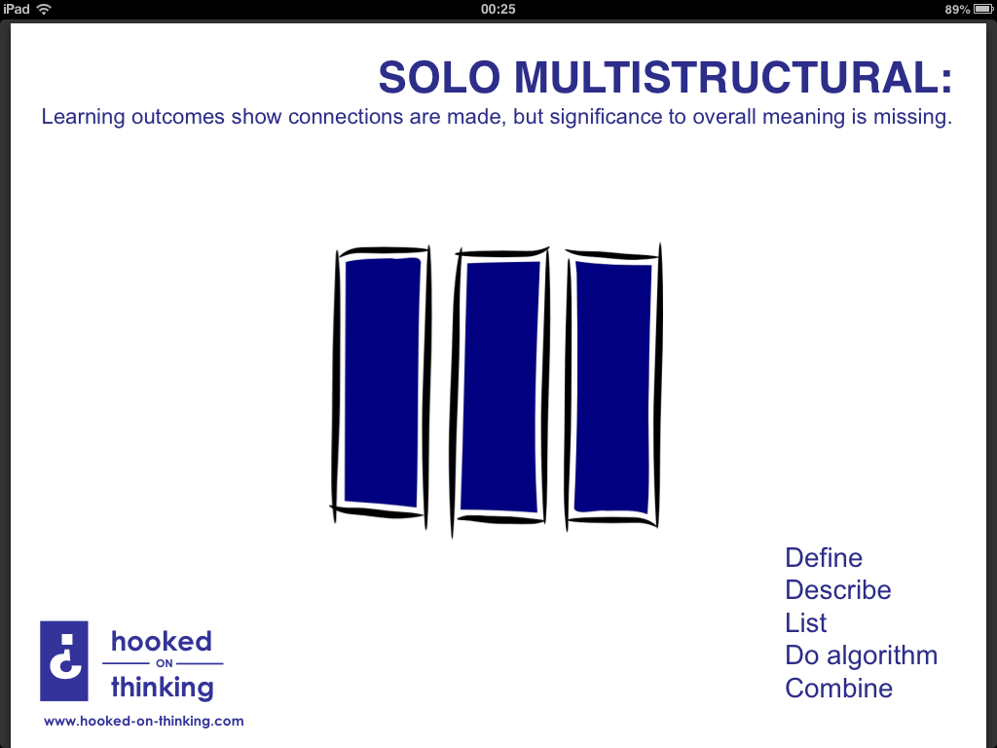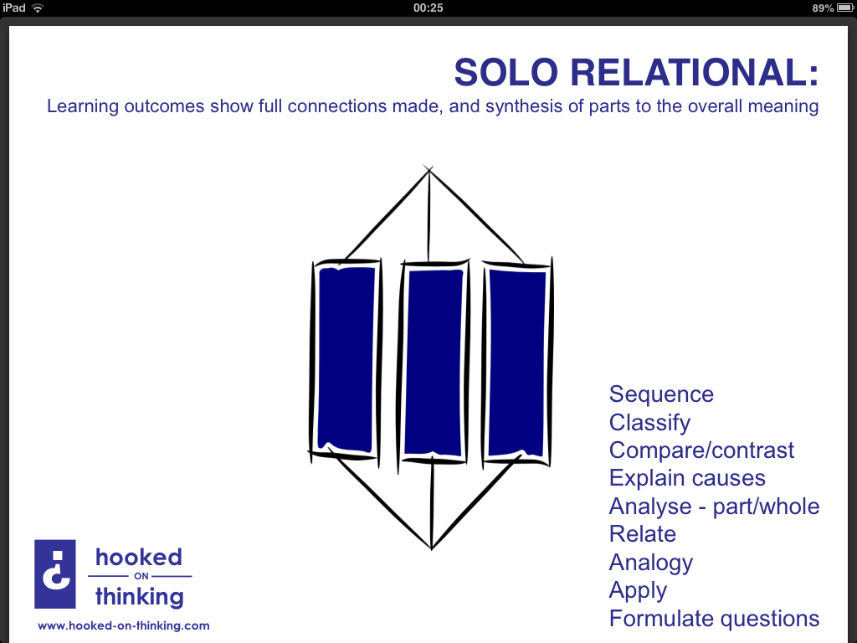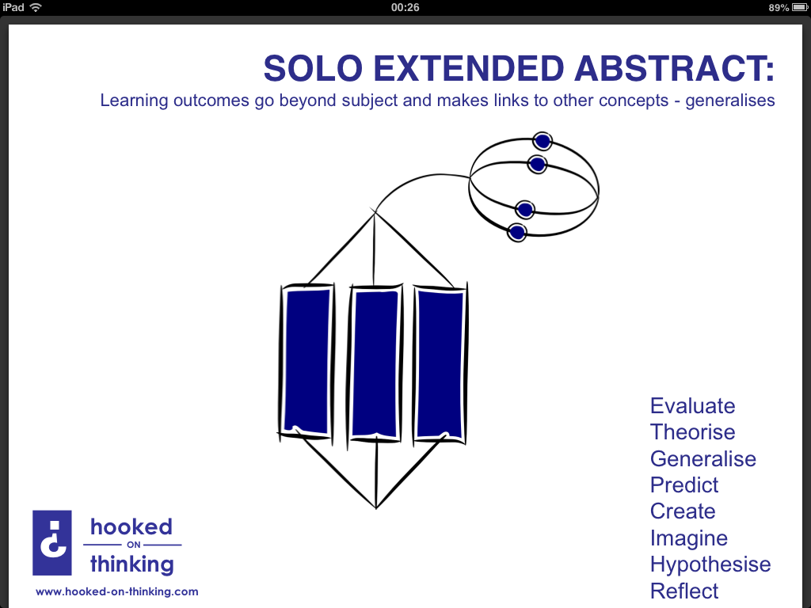groups according to your class. Students should be given sufficient time to independently formulate their own experimental design, but it is suggested you bring the group back together periodically in order that those struggling can benefit from the ideas of other students.

All groups will need a copy of the challenge instructions, a full set of practical equipment, paper and pencils and a calculator.

A health a safety briefing relating to the specific hazards of the task should be given at the start of the challenge.

**Safety**

The investigation involves a minimum of equipment and presents only low level risk from masses falling from bench height onto students' feet. Students should be advised to set up their equipment well back from the edge of the bench and to stand suitably clear when balancing their beam.

If the class extension activity is carried out, it should be done so in a clear area with suitable support available for any students involved to steady themselves when on the beam.

**How Science Works**

Discussion during the activity provides many opportunities to highlight issues of accuracy, precision and repeatability. After completing the experiment, the data should provide opportunity for discussion of sources of error, particularly relating to resolution and zero errors.

**Practical investigation**

The following activity is envisaged as requiring 1.5h for completion, allowing a further 0.5h for the extension activity.

**Learning Objectives**

Students should learn:

* that clockwise and anticlockwise moments acting on an object in equilibrium are balanced;
* the application of the principle of moments in calculations based on practical data.

**Equipment**

* Wooden metre sticks or comparable wooden beams
* Pivot (such as wooden triangular block)
* Slotted weights totalling approximately half the mass of the beam
* Bench-top balance
* Rulers with millimetre scale
* Sticky tape for marking centre of mass
* A copy of the student worksheet
* A copy of the student additional information sheet if required
* Assorted other extraneous lab equipment if required

For class extension

* Large wooden beam, such as a scaffold plank
* Suitable pivot
* Access to hand rail or suitable support for student to steady themselves
* Measuring tape
* Bathroom scales

**Lesson structure**

Use an image of children of two non-identical children on a see-saw and ask students how the see-saw could reach equilibrium even through the children have different weights.

Carry out a simple calculation such as the one included below to refresh students on the principle of moments. As well as revising the calculation, this is a good opportunity to revisit the keywords (moment, Nm, centre of mass, load, effort etc.) encountered in the topic so far.

*Child X sits on a see saw 1.5m from the pivot. Child Y balances the see saw by sitting 2.5m to the opposite side of the pivot.*

* 1. *Which child is lighter, X or Y?*
  2. *If child Y weighs 480N, what is the weight of child X?*

Set the challenge to the students - *"How much does this beam/metre stick weigh?"*

Tell students you need to know the weight (or mass if you'd like an extra step in calculations) of your beam for a practical with another class, but that you have no access to a balance to simply measure it. Using their knowledge of moments and centre of mass, can the students design an experiment to determine the beam's weight?

Show students the available equipment (also include some extraneous equipment to open up the challenge if desired), divide students into pairs/teams as appropriate and then allow them an appropriate period to discuss how they could go about the task. After a suitable period, ask groups to start drawing up their method with diagrams to explain how they will solve the problem.

Some groups may need some support here, so once groups who have independently designed experiments are drawing up their methods, scaffold other groups as needed, first by asking how they would determine the beams centre of mass etc. If necessary, students should be provided with the 'Additional information' help sheet.

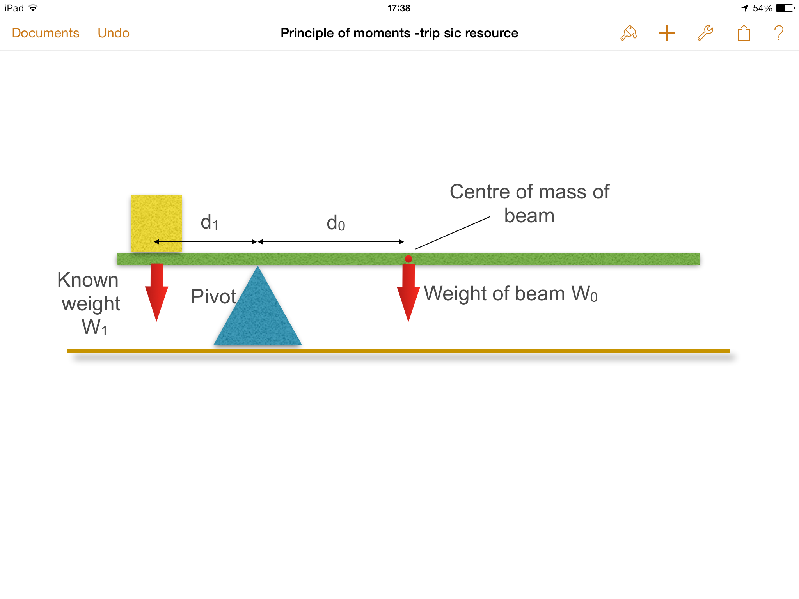Once all groups have successfully designed their experiment, they should carry out the practical investigation, recording their results. The investigation should be carried out as suggested below.

1. Determine the centre of mass of your beam and mark as accurately as possible with tape or a sticker. This can usually be done by balancing the beam on your finger, although a metre stick is obviously ideal due to the existing scale.
2. 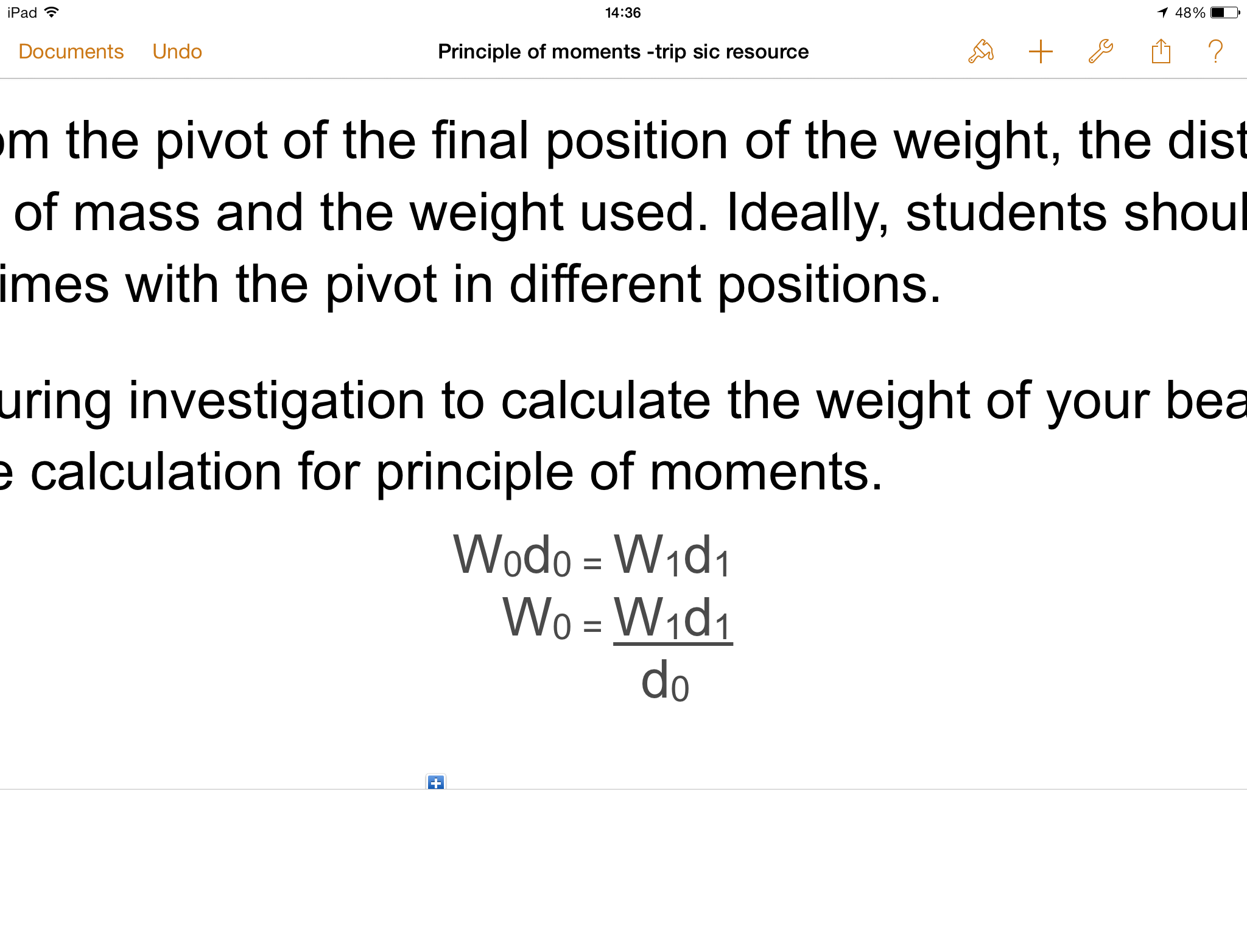Set up beam with your pivot towards one end.
3. Place a known weight (appropriate for the beam used) on the short length from the pivot, adjusting its position until the beam until the beam is balanced.
4. Record distances from the pivot of the final position of the weight, the distance from the pivot of the beam's centre of mass and the weight used. Ideally, students should now repeat the experiment several times with the pivot in different positions.
5. Use data obtained during investigation to calculate the weight of your beam using suitable rearrangement of the calculation for principle of moments.
6. Announce that a bench top balance has now been located and use to confirm weight obtained by investigation.

**Notes on practical work**

Balancing the beam may prove more difficult than expected, so sufficient time should be given.

Students will find the investigation much simpler with a symmetrical beam, although an asymmetric beam could be used to provide more of a challenge.

**Extension activity**

If time allows and if you were like to further consolidate this topic, an extension activity can be carried out as described. Using a scaffold plank or similarly your beam, recreate the investigation you have just carried out, this time using a student volunteer as the known weight (ensure the student has adequate support to steady themselves such as a bench or hand rail). Once you have calculated the weight of the plank, reverse the process and use the known weight of the plank along with the principle of moments to determine the weight of a second student or willing member of staff.

This activity simply provides more practice at rearranging and using the principle of moments calculation and could form a revision activity.

**Evidence**

A student worksheet and additional information sheet are provided as a suitable frame for students to record their work before and during the practical although neither are essential to the running of the session.

**Measuring the weight of a beam**

Using our previous work on moments and centre of mass, it is your job to to experimentally investigate and answer the following question:

*"How much does this beam weigh?"*

In order to determine the weight of the beam, you will have access to the following equipment:

* Beam/metre stick
* Pivot
* Ruler with millimetre scale
* Sticky tape
* Slotted weights
* Assorted lab equipment as supplied
* In your group, you must design a practical solution to the problem posed by a lack of a bench top balance. In the space provided, you should produce a written explanation, using diagrams and stating any calculations where appropriate, of how you intend to determine the weight of the beam. Remember to consider ways in which you can maximise the precision and reliability of your results.

|  |
| --- |
| * **Plan** * Including diagrams and equipment to be used, measurements to be taken and explanation of equations if needed. |
| * **Results/Observations** * Use this space to record any experimental data you think you will ned in an appropriate format |
| * **Calculations** * Complete any necessary calculations including formula used and units here before stating the weight of your beam   Weight of beam = |

**Measuring the weight of a beam - additional information**

**Centre of Mass.**

The centre of mass of any object is the point at which the mass of the object can thought to be concentrated. In a symmetrical object, the centre of mass lies along the line of symmetry.

**The principle of moments**

A see saw at equilibrium is an example of the principle of moments which states that

*The sum of the clockwise moments about a pivot is equal to the sum of the anti-clockwise moments about that pivot*

This can be shown with the following calculation

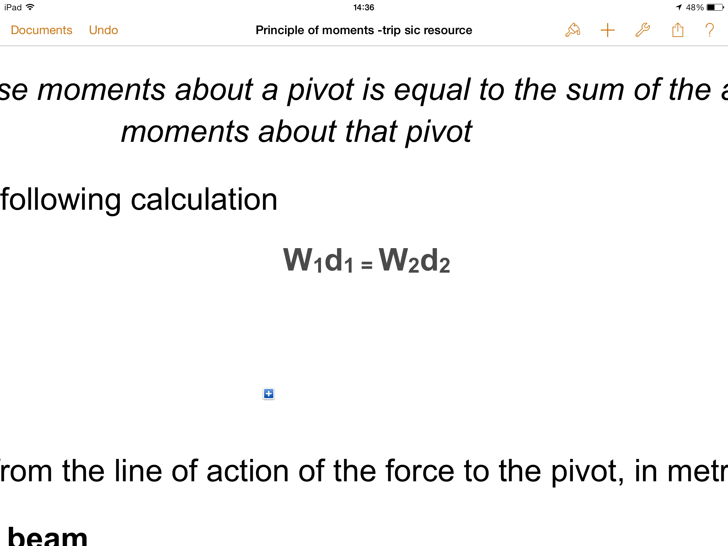

Where:

W = Weight, in Newtons, N

d = perpendicular distance from the line of action of the force to the pivot, in metres, m

**Measuring the weight of a beam**

It would be possible to measure the unknown weight of a beam by balancing it off-centre on a pivot using a known weight. By measuring the distance to the known weight and the beam's centre of mass from the pivot, it is possible to calculate the weight of the beam with a rearrangement of the above formula.